13.80: a) Taking positive displacements and forces to be upwad, 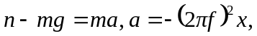 so

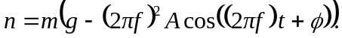

- The fact that the ball bounces means that the ball is no longer in contact with the lens, and that the normal force goes to zero periodically. This occurs when the amplitude of the acceleration is equal to 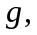or when
